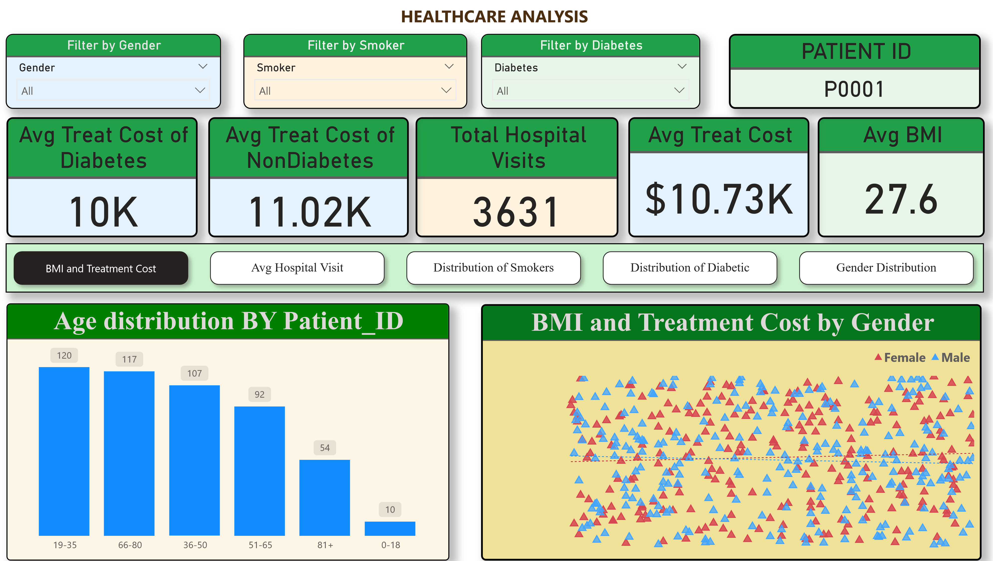
Measure Name | Formula
Avg_Treatment_Cost | AVERAGE(Healthcare[Treatment_Cost])
Avg_BMI | AVERAGE(Healthcare[BMI])
Total_Hospital_Visits | SUM(Healthcare[Hospital_Visits])
Avg_TreatmentCost_Diabetic | CALCULATE(AVERAGE(Healthcare[Treatment_Cost]), Healthcare[Diabetes] = \"Yes\")
Avg_TreatmentCost_NonDiabetic | CALCULATE(AVERAGE(Healthcare[Treatment_Cost]), Healthcare[Diabetes] = \"No\")
Avg_TreatmentCost_Smoker | CALCULATE(AVERAGE(Healthcare[Treatment_Cost]), Healthcare[Smoker] = \"Yes\")
Avg_TreatmentCost_NonSmoker | CALCULATE(AVERAGE(Healthcare[Treatment_Cost]), Healthcare[Smoker] = \"No\")
Correlation_BMI_TreatmentCost | Pearson correlation formula using SUMX, AVERAGE, SQRT

^{Power BI Desktop}


Power BI Deskto

He Report Summery

Age Insights:
Patients aged 19–35 form the largest group, but those aged 66–80 have the highest hospital visits.
Gender Insights:
The dataset is balanced (Male: 258, Female: 242), with similar hospital visit averages.
Diabetes vs Non-Diabetes:
Non-diabetic patients incur slightly higher average treatment costs ($11.02K) compared to diabetic patients ($10.40K).
Smoker Insights:
Smokers visit hospitals more often, but non-smokers spend more per treatment.
BMI vs Cost:
BMI shows weak correlation with treatment cost — other factors like age and blood pressure are stronger drivers.

